# MANUALLY CHECKING YOUR VERSION OF POWERSHELL

Windows 7

1. Open a CMD window, **not PowerShell**
2. Type or copy and paste,

powershell -command "(Get-Variable PSVersionTable -ValueOnly).PSVersion"

1. Press ENTER

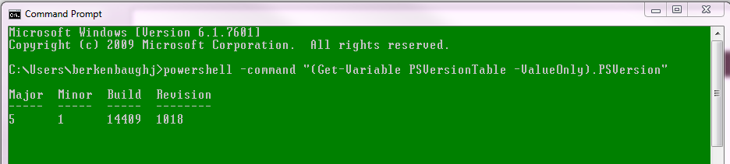

Windows 10

1. Open a CMD window, **not PowerShell**
2. Type or copy and paste,

powershell –command “$PSVersionTable.PSVersion”

1. Press ENTER

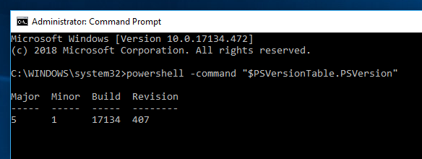

The Migration Assistant requires that you are running PowerShell version 3.0 (or greater), which shouldn’t be an issue. All releases except the earliest shipments of win7 have compatible versions. However, the company has had infrequent run-ins with older machines still running earlier versions.

The following may be of assistance if you find yourself needing to update…

[*https://docs.microsoft.com/en-us/powershell/scripting/install/installing-windows-powershell?view=powershell-6*](https://docs.microsoft.com/en-us/powershell/scripting/install/installing-windows-powershell?view=powershell-6)